**Name:** *Yuvraj Singh*

1. **Implementing the Sources**

The sources provided in the assignment were initialized and created in the *assignment5.py* script. Those sources are located under the *def create_sources* method.

1. **Describing the Global Schemas**

The global schema provided in the assignment were created in the *def create_global_schema* method in the *assignment5.py* script. Two versions of the schema were created, a non-materialized view and a materialized view.

1. **Custom Queries over the Global Schema**

In the assignment, two queries had to be created using the global schema. Those queries are in the *def queries* method of *assignment5.py*. The method performs the queries and prints out the first ten entries in the result.

1. **Expanding the Custom Queries**

Using the custom queries from the previous section of the assignment, new queries were made where the queries were expanding using the GAV mapping definitions over the sources. By running the *def expanded_queries* method, the newly expanded queries were performed and the execution time for each query (Materialized and Non-Materialized) were printed out.

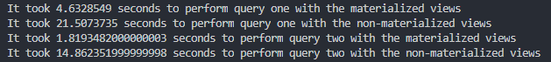

1. **Optimizing the Custom Queries**

The queries in the previous section were optimized by eliminating redundant joins and sources. The optimized queries are executed in the *def optimized_queries* method. Below is a side-by-side comparison of the extended queries and then the optimized queries. We can see that the optimized did make quite the difference for both queries

Query #1 (Materialized):

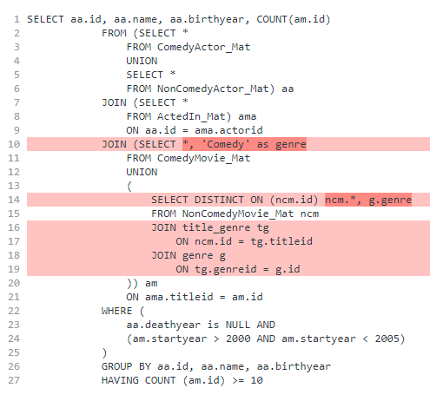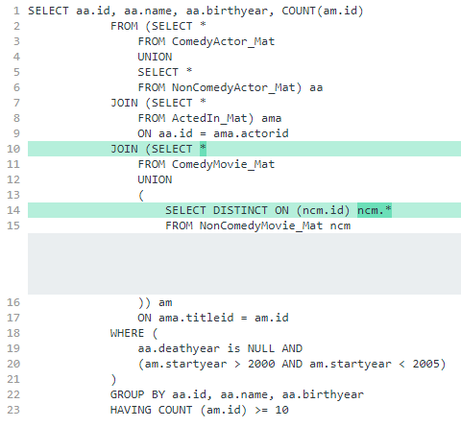

Query #2 (Materialized):

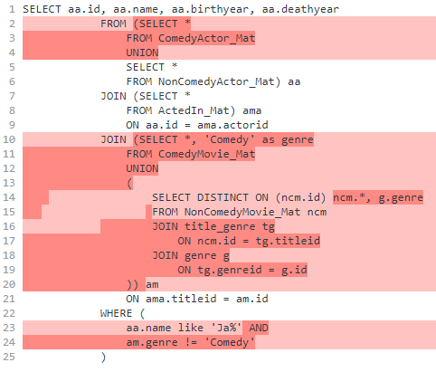

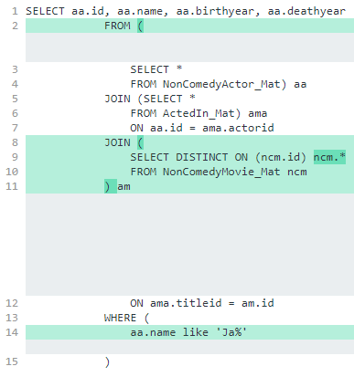

Timing:

